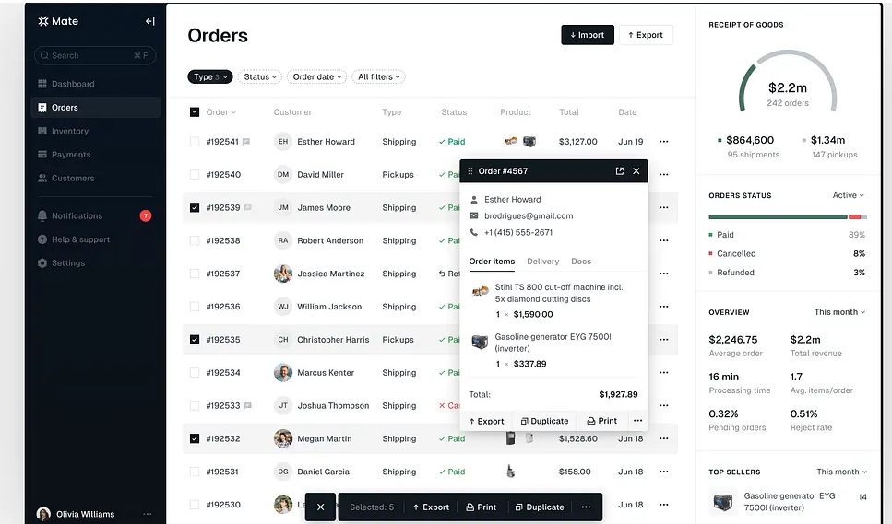

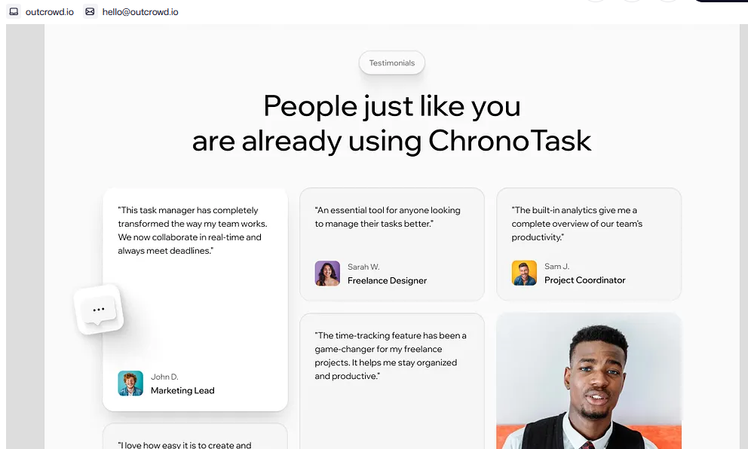

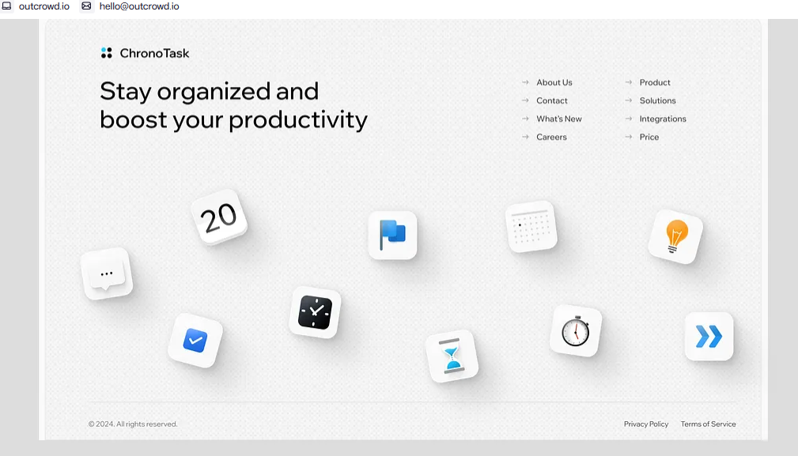

https://dribbble.com/shots/25000009-ChronoTask-Landing-Page?utm_source=Clipboard_Shot&utm_campaign=outcrowd&utm_content=ChronoTask%20-%20Landing%20Page&utm_medium=Social_Share&utm_source=Clipboard_Shot&utm_campaign=outcrowd&utm_content=ChronoTask%20-%20Landing%20Page&utm_medium=Social_Share

